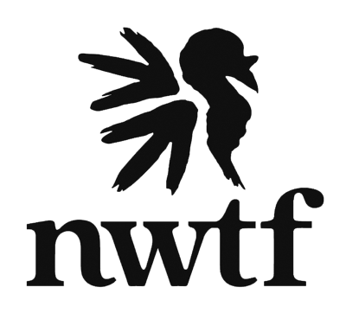

South Carolina State Chapter
National Wild Turkey Federation

Leadership Workshop Weekend
Hickory Knob, McCormick, SC
September 22-25th, 2022

RSVP Form

Name_____________________________

Chapter______________Hometown____________

_____I will attend (enclosed is my $75 check payable to SC NWTF)

_____I regret I will be unable to attend

Please return this form by 9-15-2022 to:

Mike Waters
1318 Rock House Rd
Greenwood, SC 29646

