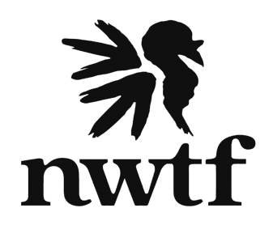

South Carolina Leadership Workshop 2022
September 22-25, 2022

Thursday, September 22nd, 2022
7:30pm Dinner (Optional)

Friday, September 23rd, 2022
8:00 – 9:00 am Breakfast
9:00am – 9:15 am Welcome – Dennis Waters
9:15 am – 9:30 am NWTF National Board President - Bryan Perry
9:30 am – 10:15 am SC DNR Director - Robert Boyles
10:15 am – 10:45 am NWTF Co-CEO - Jason Burckhalter
10:45 am – 11:00 am Break
11:00 am – 11:20 am NWTF Biologist – Ricky Lackey
11:20 am – 11:50 am TNC – The Nature Conservatory
12:00 pm – 1:00 pm Lunch
1:00 pm – 2:00 pm NWTF Regional Directors Updates - Mike & Bobby

Saturday, September 24th, 2022
8:00 – 9:00 am Breakfast
9:00 am – 9:15 am Welcome - Dennis Waters
9:15 am – 10:15 am USFS, Long Cane District – Donnie Ray
USFS, Enoree District - Tarri McKinney
USFS, Matthew Malbert
USFS, Andrew Pickens - Jeff Magniez
10:15 am – 10:30 am Break
10:30 am – 11:00 am Long Leaf Alliance
11:00 am – 11:30 am DNR – Charles Ruth
11:30 am – 12:30 pm Lunch
12:45 pm SC State Board Meeting
6:30pm Dinner – (Optional $20 Steaks or left overs)

Sunday, September 25th, 2022
Depart

